­­­Hooli XYZ

**Sprint 3 Report**

**Sprint Period:** 12/04/2016 – 03/05/2016

**Members:­**

Connor Beardsmore – 15504319

Brendan Lally – 18407220

Adam Brown – 18338993

Jordan Chou – 18348691

Edward Lim - 18339145

**Table of Contents:**

1. Sprint Planning
2. SCRUM Meetings
3. Sprint Review
4. Sprint Retrospective

Appendix A: CSV of all user stories

Appendix B: Screenshots of Functionality

**1. Sprint Planning**

**User Stories:**

The following user stories were selected for completion in Sprint 3.

|  |  |  |  |
| --- | --- | --- | --- |
| Number: | User Story: | Area: | Effort Points: |
| 1 | As a User, I want to edit my submissions so that I can fix spelling errors. | Posting Submission | 2 |
| 2 | As a User, I want to comment on a submission so that I can voice my support of the idea. | Commenting | 2 |
| 3 | As a User, I want to suggest improvements to a submission so that I can improve on an idea. | Commenting | 2 |
| 4 | As a User, I want to edit my comments so that I can fix spelling errors. | Commenting | 5 |
| 5 | As a User, I want to edit my improvements so that I can fix spelling errors. | Commenting | 5 |
| 6 | As a User, I want to delete my comment so that I can remove my comment. | Commenting | 3 |
| 7 | As a User, I want to delete my improvement so that I can remove my improvement. | Commenting | 3 |
| 8 | As an Admin, I want to delete improvements so that I can remove inappropriate improvements. | Commenting | 3 |
| 9 | As an Admin, I want to edit improvements so that I can remove inappropriate language in an improvement. | Commenting | 3 |
| 10 | As an Admin, I want to delete comments so that I can remove inappropriate comments. | Commenting | 3 |
| 11 | As an Admin, I want to edit comments so that I can remove inappropriate language in comments. | Commenting | 3 |
| 12 | As a User, I want to down-vote on submissions so that I can acknowledge submissions I dislike. | Voting | 3 |
| 13 | As a User, I want to up-vote on submissions so that I can acknowledge submissions I like. | Voting | 3 |
| 14 | As a User, I want to see the total votes for a submission so that I can see how popular it is. | Voting | 1 |
| 15 | As a User, I want to sort submissions based on date so that I can see the newest submissions. | Viewing Submissions | 5 |
| 16 | As a User, I want to sort submissions based on popularity so that I can see the most popular submissions. | Viewing Submissions | 5 |
| 17 | As a User, I want to sort submissions based on views so that I can see the most popular submissions. | Viewing Submissions | 3 |
| 18 | As a User, I want to categorize my submission so that other users can find it easily. | Viewing Submissions | 3 |
| 19 | As a User, I want to view submissions based on category so that I can view relevant submissions. | Viewing Submissions | 5 |
| 20 | As a User, I want to search all submissions so that I can find one relevant to my field of study. | Viewing Submissions | 5 |

**Sprint Goal:**

Sprint 3 is potentially the most crucial in the project, with a significant amount of work still to complete with only 2 sprints remaining. Thus, numerous user stories from various categories were chosen to be implemented. The main Sprint goal was to implement the comment functionality and enhance the submission implementation.

**Task Breakdown:**

The user stories for the sprint were broken down into simpler high-level task units. These tasks must be finished before the user stories can be reviewed, accepted and completed:

* Create Comments / Improvements model
* Create Comments / Improvements form
* Create Comments / Improvements template
* Create comment links and URL's
* Add sorting buttons to submission view
* Create views based on sorting criteria
* Modify Submission Model to include votes
* Create Voting Model
* Add up-vote and down-vote buttons
* Create edit and delete button for submission
* Implement backend edit functionality
* Implement backend delete functionality
* Create edit form
* Redirect link to submission page with editable fields populated

**Task Distribution:**

|  |  |
| --- | --- |
| Members: | Area of Focus: |
| Jordan, Connor | Viewing Submissions. Sorting and Searching. |
| Jordan, Adam | Commenting. Posting, Editing and Deleting. |
| Brendan, Edward, Connor | Voting. Up-vote, Down-vote and Total votes. |

**Effort Estimation:**

The team produced effort estimations through discussion within the first team meeting of the sprint. The stories related to sorting the submissions have high time estimations as they require significant modifications to the HTML templates, backend views and the submission model. The editing submissions story is equally high for related reasons. Deleting submissions is a relatively simple task and thus its estimation reflects this. Once edit and delete is implemented for Submissions, the functionality can be adopted to edit and delete comments. This will require few changes and the relevant user stories take should take little time.

**2. SCRUM Meeting**

**Meeting #1 : 13/04/16**

|  |  |  |  |
| --- | --- | --- | --- |
| Members: | Completed | Uncompleted | Issues |
| Jordan, Connor | - | (15) (16) (17) (18) (19) (20) | - |
| Jordan, Adam | - | (2) (3) (4) (5) (6) (7)  (8) (9) (10) (11) | - |
| Brendan, Edward, Connor | - | (1) (12) (13) (14) | - |

**Meeting #2 : 19/04/16**

|  |  |  |  |
| --- | --- | --- | --- |
| Members: | Completed | Uncompleted | Issues |
| Jordan, Connor | (15) (16) (17) (18) (19) (20) | - | - |
| Jordan, Adam | (2) (3) (8) (9) (10) (11) | (4) (5) (6) (7) | Edit / Delete comment code just needs documenting. |
| Brendan, Edward, Connor | (1) | (12) (13) (14) | - |

**Meeting #3 : 25/05/16**

|  |  |  |  |
| --- | --- | --- | --- |
| Members: | Completed | Uncompleted | Issues |
| Jordan, Connor | (15) (16) (17) (18) (19) (20) | - | - |
| Jordan, Adam | (2) (3) (4) (5) (6) (7)  (8) (9) (10) (11) | - | - |
| Brendan, Edward, Connor | (1) (12) (13) (14) | - | Voting models may need modifying within the next Sprint for extensibility. |

**Early Finish:**

The team finished all user stories a week earlier than expected during Sprint 3. This high productivity from the team was a result of high work ethics and a lower external workload for team members. The last week of the sprint however, team members had limited time to work on the project. Instead of attempting to bring user stories forward, we unofficially started basic implementations for user stories in preparation for next sprint. We also worked to document our code extensively and "clean up" our code for better extensibility.

**3. Sprint Review**

**Completed User Stories:**

* As a User, I want to edit my submissions so that I can fix spelling errors.
* As a User, I want to comment on a submission so that I can voice my support of the idea.
* As a User, I want to suggest improvements to a submission so that I can improve on an idea.
* As a User, I want to edit my comments so that I can fix spelling errors.
* As a User, I want to edit my improvements so that I can fix spelling errors.
* As a User, I want to delete my comment so that I can remove my comment.
* As a User, I want to delete my improvement so that I can remove my improvement.
* As an Admin, I want to delete improvements so that I can remove inappropriate improvements.
* As an Admin, I want to edit improvements so that I can remove inappropriate language in an improvement.
* As an Admin, I want to delete comments so that I can remove inappropriate comments.
* As an Admin, I want to edit comments so that I can remove inappropriate language in comments.
* As a User, I want to down-vote on submissions so that I can acknowledge submissions I dislike.
* As a User, I want to up-vote on submissions so that I can acknowledge submissions I like.
* As a User, I want to see the total votes for a submission so that I can see how popular it is.
* As a User, I want to sort submissions based on date so that I can see the newest submissions.
* As a User, I want to sort submissions based on popularity so that I can see the most popular submissions.
* As a User, I want to sort submissions based on views so that I can see the most popular submissions.
* As a User, I want to categorize my submission so that other users can find it easily.
* As a User, I want to view submissions based on category so that I can view relevant submissions.
* As a User, I want to search all submissions so that I can find one relevant to my field of study.

**Unfinished User Stories:**

There were no user stories left unfinished at the conclusion of this Sprint period.

**Review Data:**

* Total Stories: 46
* Completed: 32
* Uncompleted: 14
* Total Progress: 70%

**Review Data:**

The statistics and data within the figures below were produced via the Pivotal Tracker software utilized by the team. They illustrate the progress throughout the current iteration and progress towards the final release.

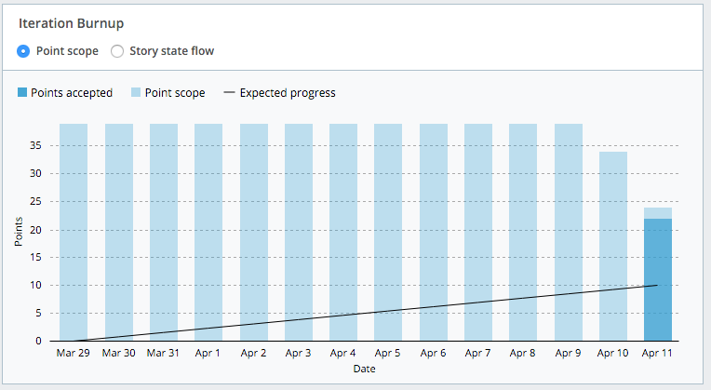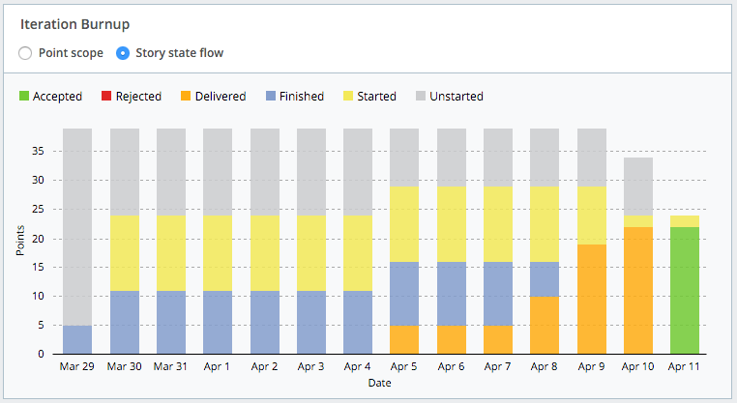

Figure 1: Iteration Burnup - Points and Stories

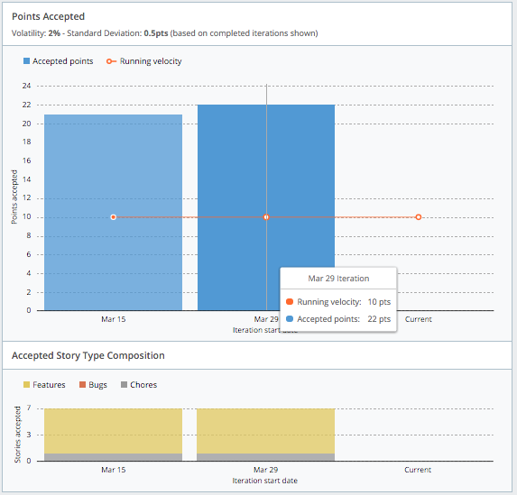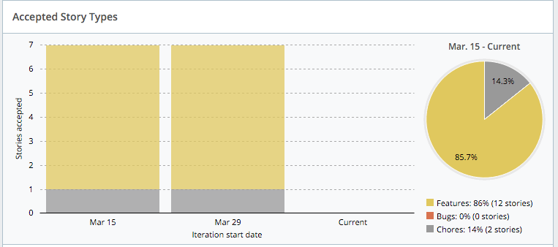

Figure 2: Points Accepted

Figure 3: Accepted Story Types

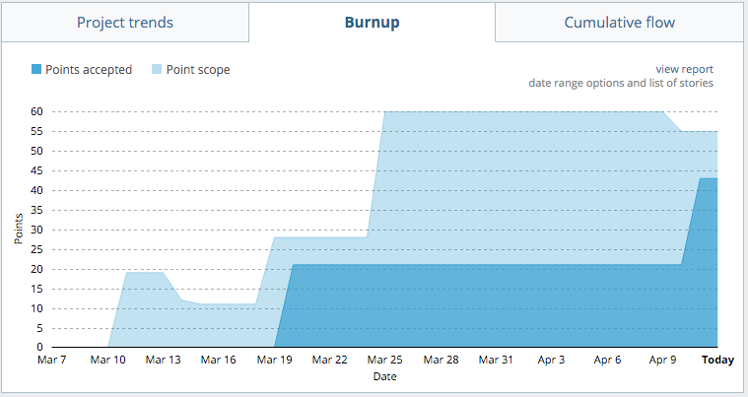

Figure 4: Overall Burnup

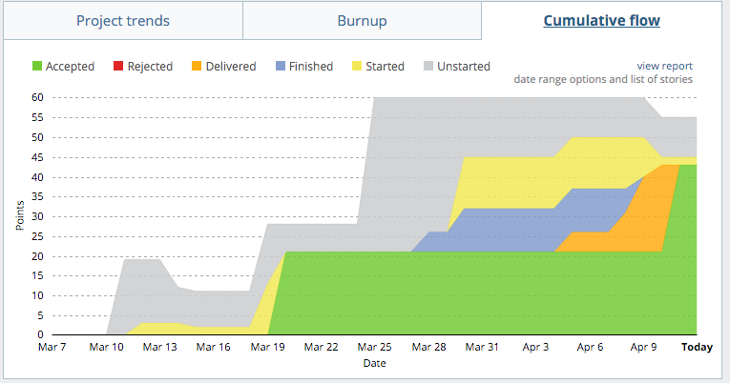

Figure 5: Cumulative Flow Chart

**4. Sprint Retrospective**

**Sprint Ratings**

* Communication: 8/10
* Performance: 9/10
* Work Ethic: 9/10

**What went well?**

A total of 20 user stories were completed in the Sprint, reducing the work required in the next sprint. With 20 stories being completed, a significant amount of functionality was implemented in the site and this is evident upon viewing the final product. Despite having 2 weeks without Tutorials and a study-free break, communication within the team was very strong. In our Sprint 2 retrospective we aimed to have short informal online meetings and this was achieved during this Sprint. Our regular team meetings still went ahead, regardless of members not being on campus This high communication level also resulted in no duplicated work for this Sprint. All members completed the work that they chose to complete and no imperative issues were raised in the Sprint meetings. We also finished our stories early for the sprint, giving us time to enhance the overall quality of the product to a greater level. This high productivity was linked to the pair programming utilized within the Sprint.

**We want to keep doing:**

We want to ensure this high level of productivity is maintained throughout the final sprint period. Since this productivity was a by-product of pair programming, we will continue to use this technique in the future. The aim is also to finish early in the next sprint, allowing us to finalize the product for release. Since the high level of communication within the last sprint significant assisted our work, we aim to uphold this communication level as we progress forward.

**What did not go well?**

While overall the Sprint was a major success, there were minimal aspects that were not beneficial to the team. Due to the lack of tutorials, we have not had a chance to meet with the product owner for the entire sprint. There were no significant issues as a result of this however so its impact was negligible. As a result of the high productivity levels, numerous team members were modifying the same code concurrently. This resulted in numerous merge conflicts on the BitBucket platform, which resulted in wasted time overheads.

**We want to start:**

As this sprint was highly productive, we want to perform the same during every upcoming sprint. Our code documentation could be improved and thus, we aim to document code extensively as we progress. All code must be extensively documented before it is accepted as complete from this Sprint onwards. This will enable other team members to understand code much more easily. We also want to start tracking common defects similar to how we do in the PSP and hope to have a primitive defect log complete by the end of the next Sprint. This will help team members troubleshoot problems when they arise, as a log of common defects will be kept.

**Appendix B: Screenshots of Functionality**

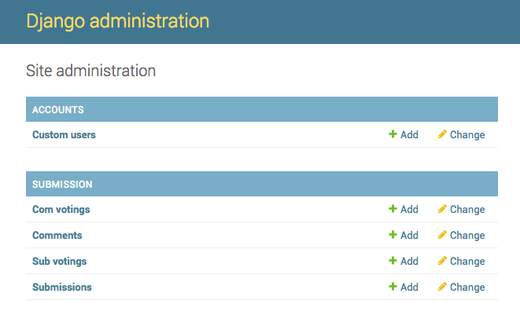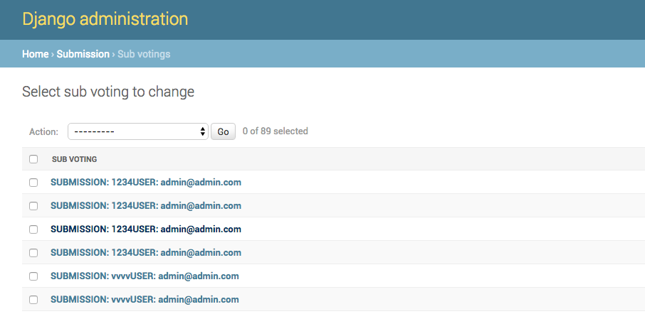

Figure 6: Django Admin Platform

Figure 7: "Sub Voting" Model

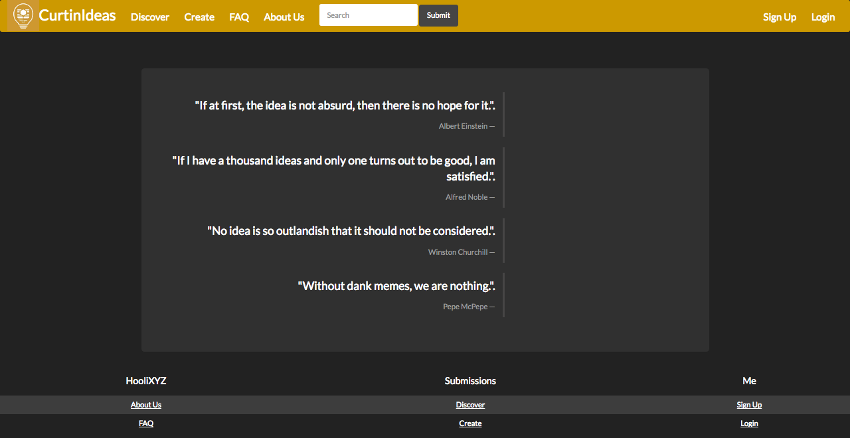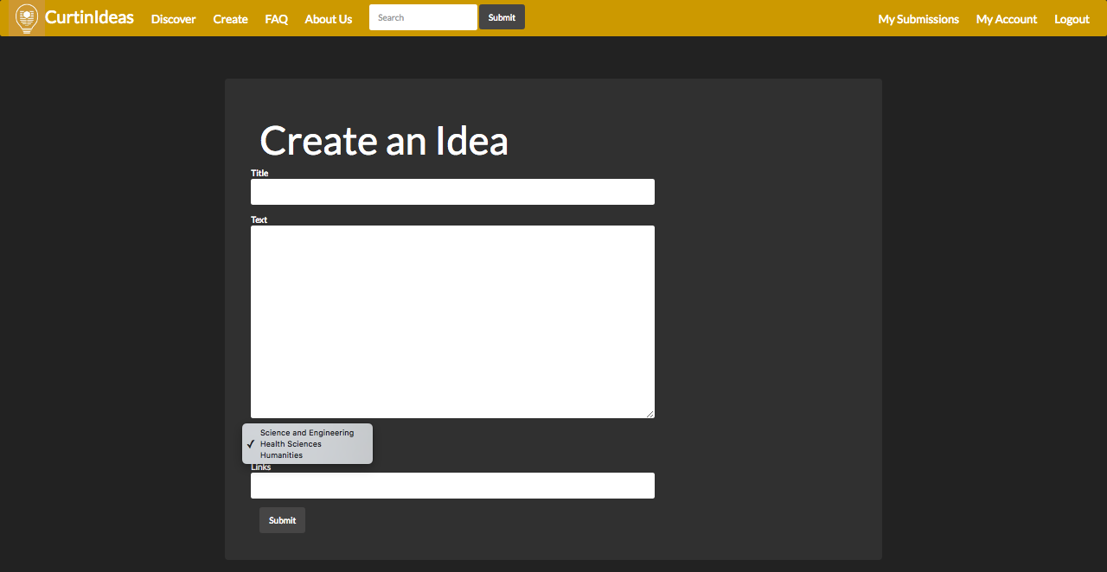

Figure 8: Home Page

Figure 9: Create Submission

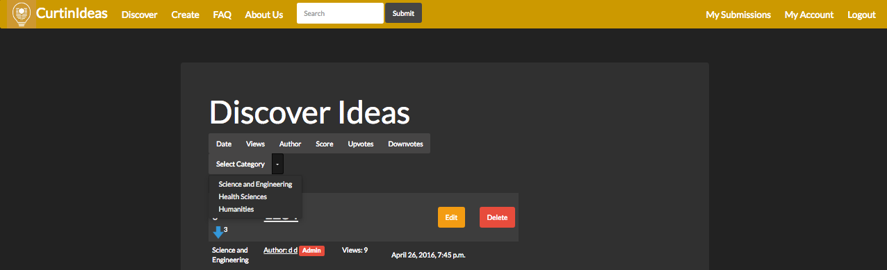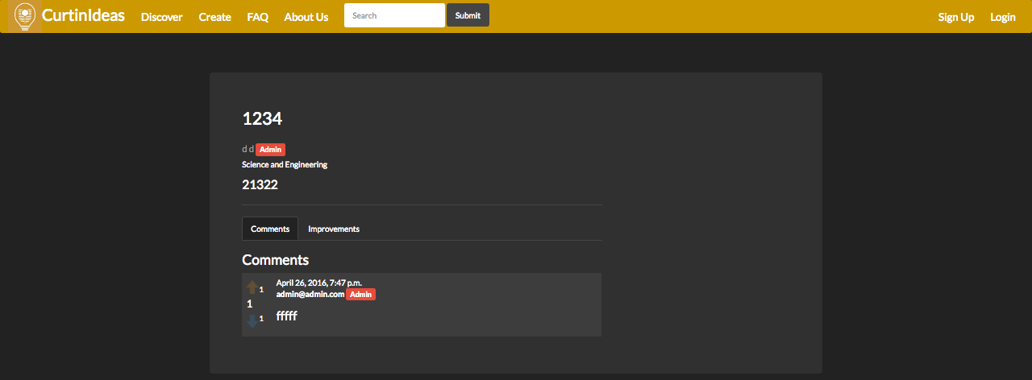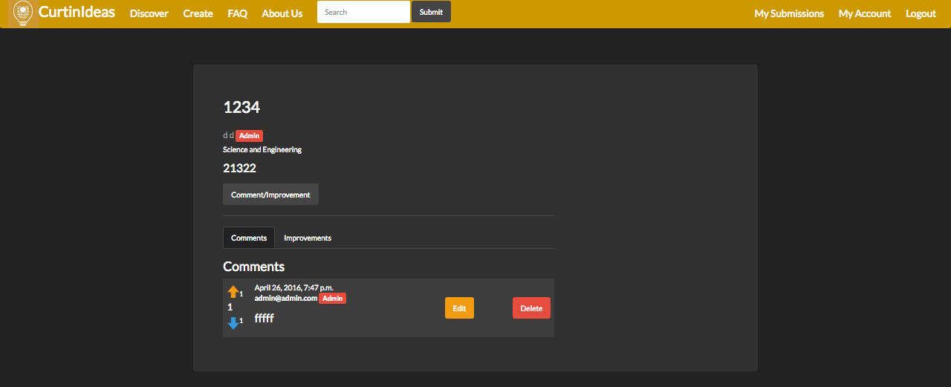

Figure 10: Sorting Submissions

Figure 10: Comments View - My Comment

Figure 11: Comments View - Standard